CIM User Group Meeting
Genval (Belgium), 12-15 May 2009

Please fill in this form (typed) and send it back by e-mail or fax

To be returned to the hotel by 20 April 2009


Tel.: + 32 2 655 74 37
Fax: + 32 2 655 74 44
Email: resa.cdl@martinshotels.com
Website: www.martinshotels.com

HOTEL BOOKING FORM

Price for the stay: Single: 180€ Double: 220€
Above rates include 21% service and 6% VAT and Buffet breakfast

NAME: | CREDIT CARD Details:  TYPE:
ARRIVAL DATE: | ❒ Visa  Amex  Mastercard  Diners
DEPARTURE DATE: | NUMBER:
COMPANY: | EXPIRY DATE:
ADDRESS: | CVC Code:  (3 digit code on the back of the creditcard)
POSTCODE & CITY: | SIGNATURE:
COUNTRY: | SIGNATURE:
E-MAIL: | SIGNATURE:
FAX NUMBER:  PHONE NUMBER: | SIGNATURE:

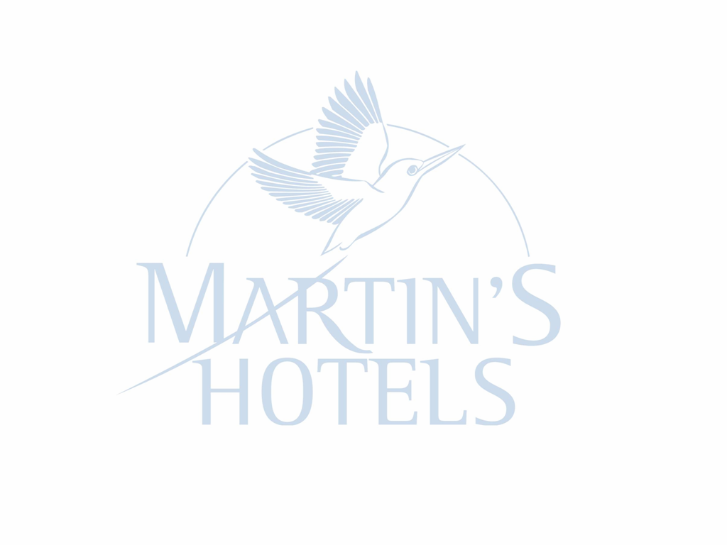
Reservation for taxi (70€ one way)
Please book a taxi for … persons at … Zaventem Airport/ Midi Station
Number of flight/train:

Signature: __________________________ Date: _________________________

